# **3D stereo camera – ground robot tracking algorithm**

## Hardware instructions Appendix

When operating the robot , one needs to connect by wire , to the USB terminal port.

Connecting by serial with micro-usb to usb cable, in 115200 baud rate.

With application such as ‘teraterm’.

After startup and seeing:

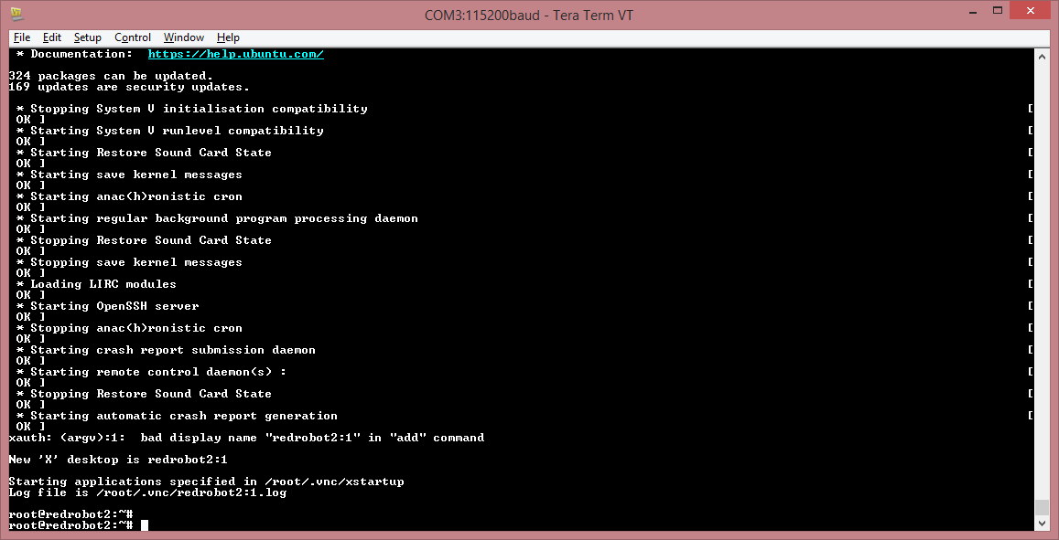

Enter the next commands:

nmcli nm - for wifi status

nmcli d wifi connect XX password 1234567890 - for the connection (XX is the SSID name)

verify connection by running ‘nmcli nm’ again.

Ip addr – to verify the assigned address.

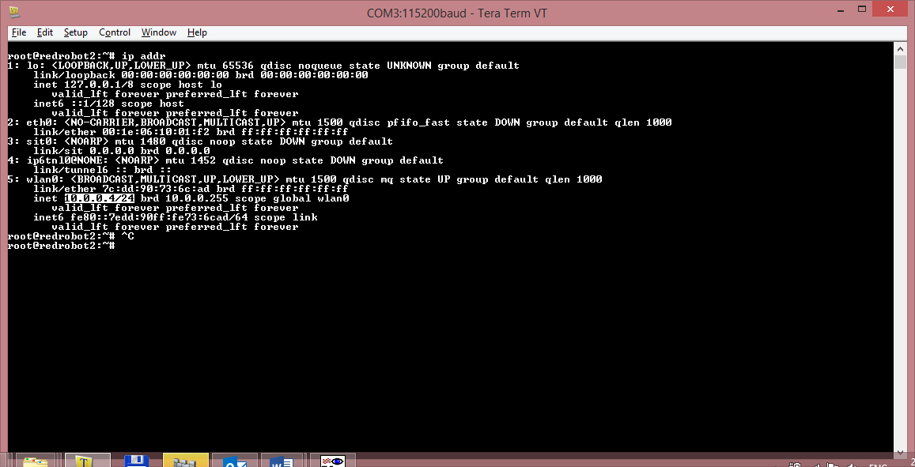

vncserver – to start the X-server application.

Open VNC to connect with X terminal.

Connect to IP:X , where IP is the given address from above, X is the number of the activated vncserver.

Password is 12345678

Entering the screen:

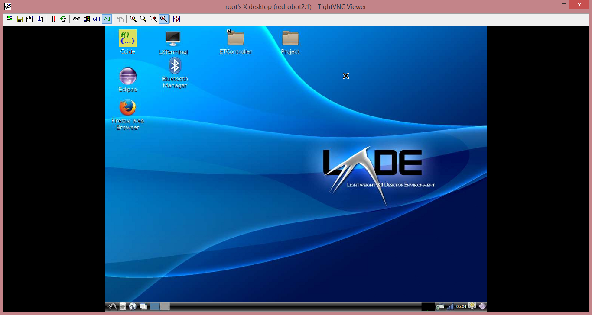

Compiling & Running the project through VNC-server:

Open Eclipse and run the project.

Note to set , before run, the DISPLAY number, according to the number of VNC connection .

